TNA Collection Care ResearchSpace

Quick Manual for version 2
Draft

Kartography CIC

TNA Collection Care ResearchSpace 1
Quick Manual for version 2 1
Background 3
Concepts 3
Summary of Workflow 3
Clipboard 4
Start a New Project 4
Saving the Project 5
Exhibitions and Loans 11

Background
The objective of the Collection Care ResearchSpace system is to represent the skills and knowledge of the CCD department as part of their everyday work including research projects - and then to provide a basis for internal training, decision making, collaboration and public dissemination.
The current version has converted a previous administrative system and introduced greater detail and new semantic concepts.

Concepts
ResearchSpace - is a fully Semantic Web application. All authored content is Linked Data using the semantic ontology CIDOC CRM. This data can be used for collaboration and dissemination. Its semantic precision means an end to expensive data cleaning, an end to expensive publishing infrastructures, meaning for collaboration and the ability to add much needed historical and social context. .
Kartography CIC - is a social enterprise company. Its charter includes the development of community software and information that addresses data diversity and contextualisation.
Dynamic Development - the CCD system is constantly changing allowing the department to reflect changes in its practices. Incremental changes can be made to the system easily.

Summary of Workflow
CCD work can actually start anyway in the system but a project framework has been created. A project provides information about the nature of the project whether it be a basic process or more complex research. Projects consist of material items which might be from the collection or elsewhere. Projects consist of activities like assessments, treatments, analysis, loans and surveys. However, these activities can be extended.
Menu (Left side)

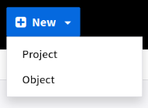
The menu on the left of the screen has a home page button which provides a list of current projects, a search button link which provides access to semantic search, a Resources button which provides access to different tools, and a new button.
Currently two items appear in the New menu - Project and Object.
The project link starts the process of creating a new project. The object link allows the creation of a new item, or allows an item to be imported from the TNA archive Discovery system.
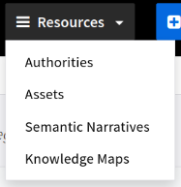
The Resources menu item provides access system system authorities, assets (videos, images, etc) and to Semantic Narratives and Knowledge Maps. Authorities are the vocabularies and entity authorities used and maintained in the system

Clipboard
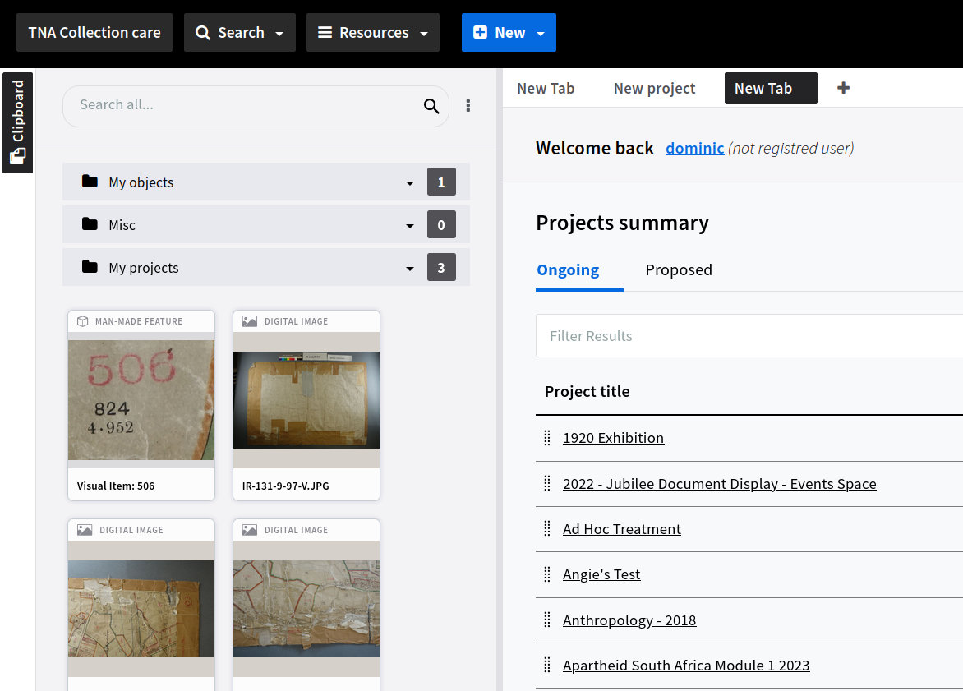
The clipboard allows items to be added to a personal folder structure for quick access and for using parts of the system using a drag and drop system. For example, the listed projects in the image can be dragged into the clipboard. Equally, items can be dragged out of the clipboard as part of processes in the system

Start a New Project
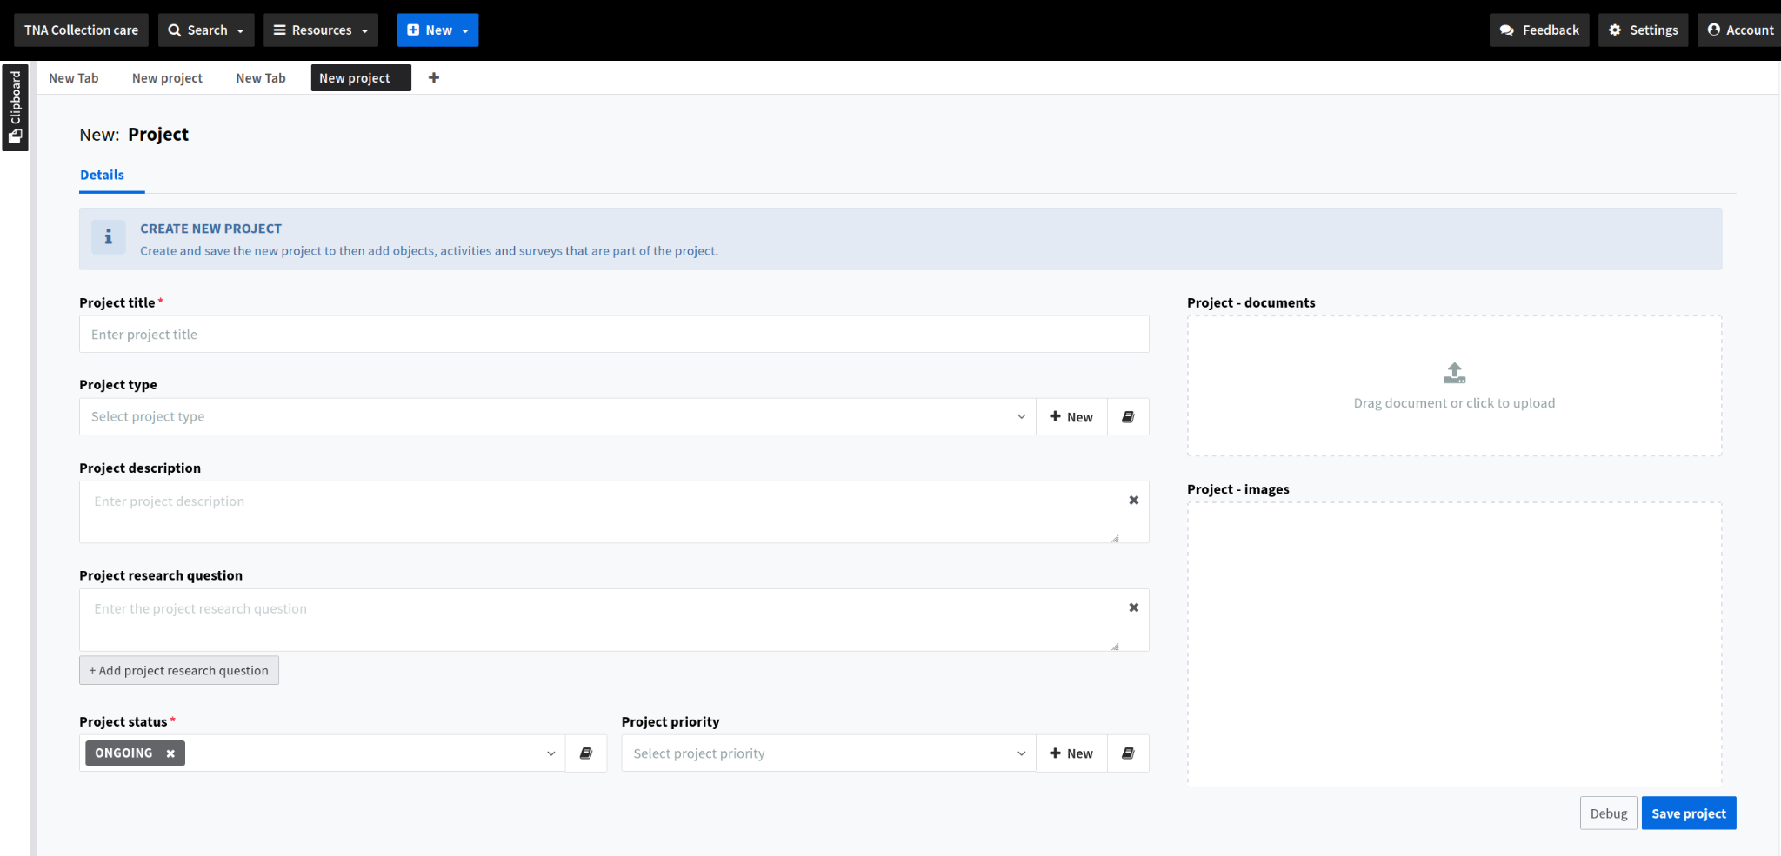
A new project provides the means to add basic information. This includes research questions which can be used to provide a context for processes in the system. E.g. This activity is related to a particular question.
Project type may alter the behaviour of the system, but all project types can include any activity.
When the Project information is completed then different options appear.
Note that new authority terms can be created as forms are completed. For example, a new project type can be created. This can be achieved with an inline form or going directly to the authority or vocabulary using the document link.
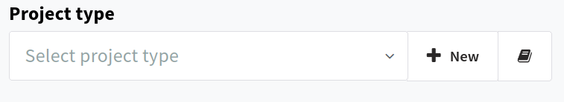

Note - Frame System
The system uses a frame system. This allows different frames of information to be on screen at the same time. Frames can be positioned by dragging from the frame tab at the top of the frame. Applicable items can be dragged between frames. In the example below the project type vocabulary has been opened and dragged to create two views on the screen. A term can be dragged from the vocabulary list into the form if required.
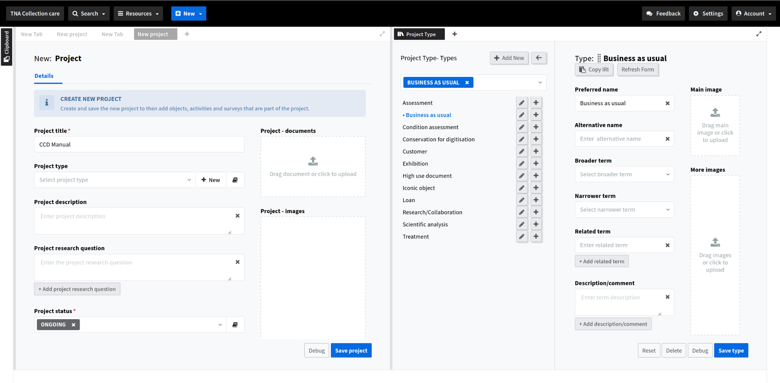
One aim of the system is to keep all related information within the same knowledge graph. In most areas of the system the ability to drag or upload documents and images into the system is provided and encouraged to build a richer picture.

Saving the Project
After ensuring that the mandatory fields are completed (any field can be made mandatory) new tab items appear.
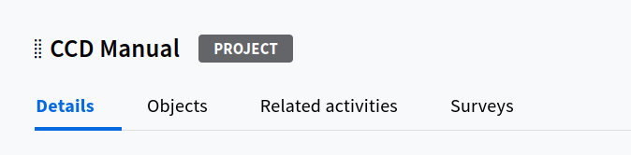
Note that a screen shows its process type next to the title.

Adding Objects
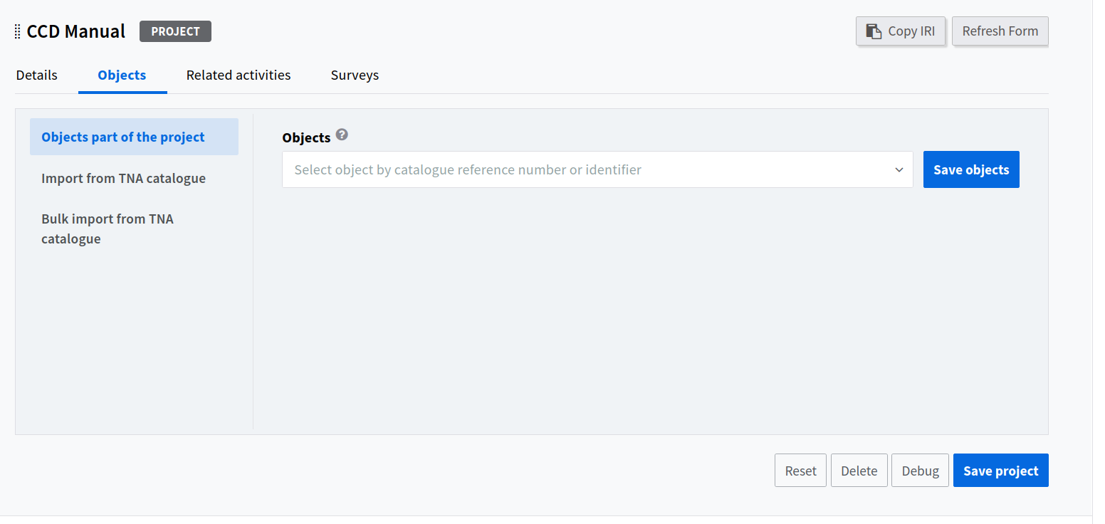
ResearchSpace has the ability to interface with other databases and API’s, import and convert data into Linked Data. In the CCD system it interfaces with the TNA’s Discovery system and allows CCD staff to search and import at series, piece or item levels. It keeps these imports in sync with Discovery. This can be achieved with any collection system. Simple typing (text or ids) provides a list of candidates (other information like titles and descriptions can be added to the search). If the item is already in the system then this is indicated and can just be added without importing again.
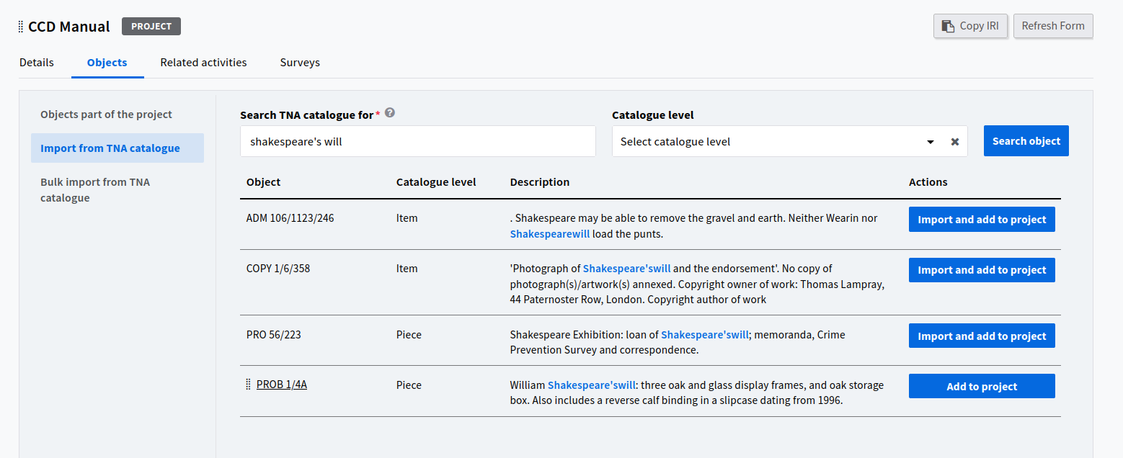
In this example, the objects are saved to the project and are listed. Clicking on an item in the list creates a new frame with the details of the item. They can also be dragged to the clipboard.
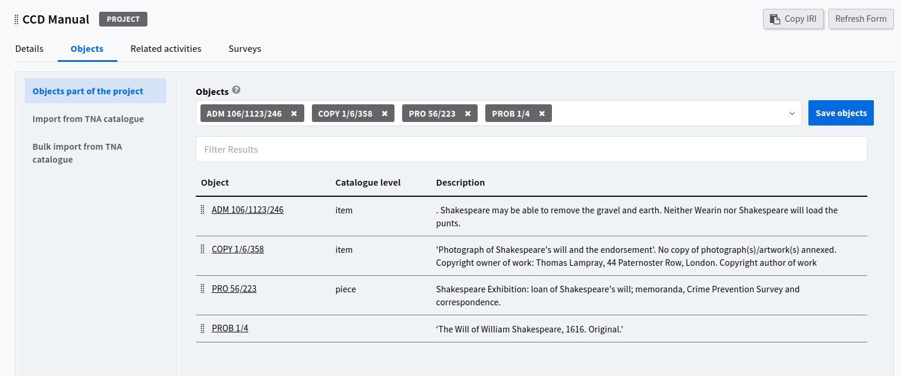
Related Activities
Once objects have been added to the system activities related to them can commence.
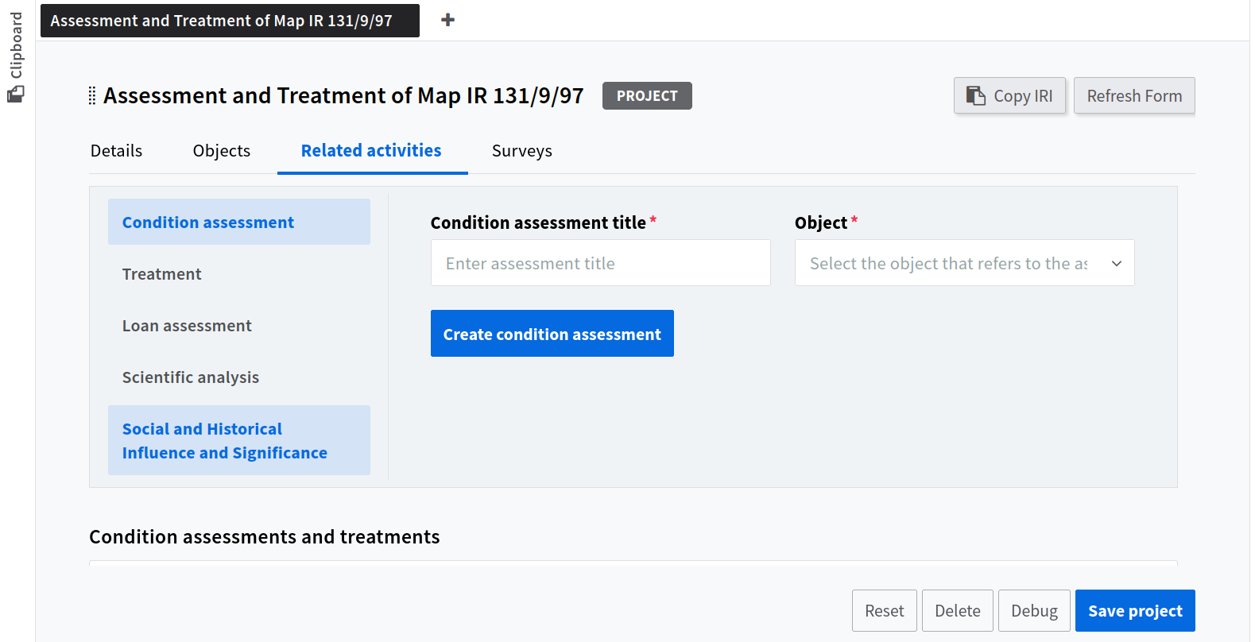
Moving to the next tab, activities can commence. These activities can be various and added. An activity is started by entering a title (auto titles can be used), selecting an object and creating the activity. This results in a new record which appears in a table. Using the link to this record provides the full information input for it.
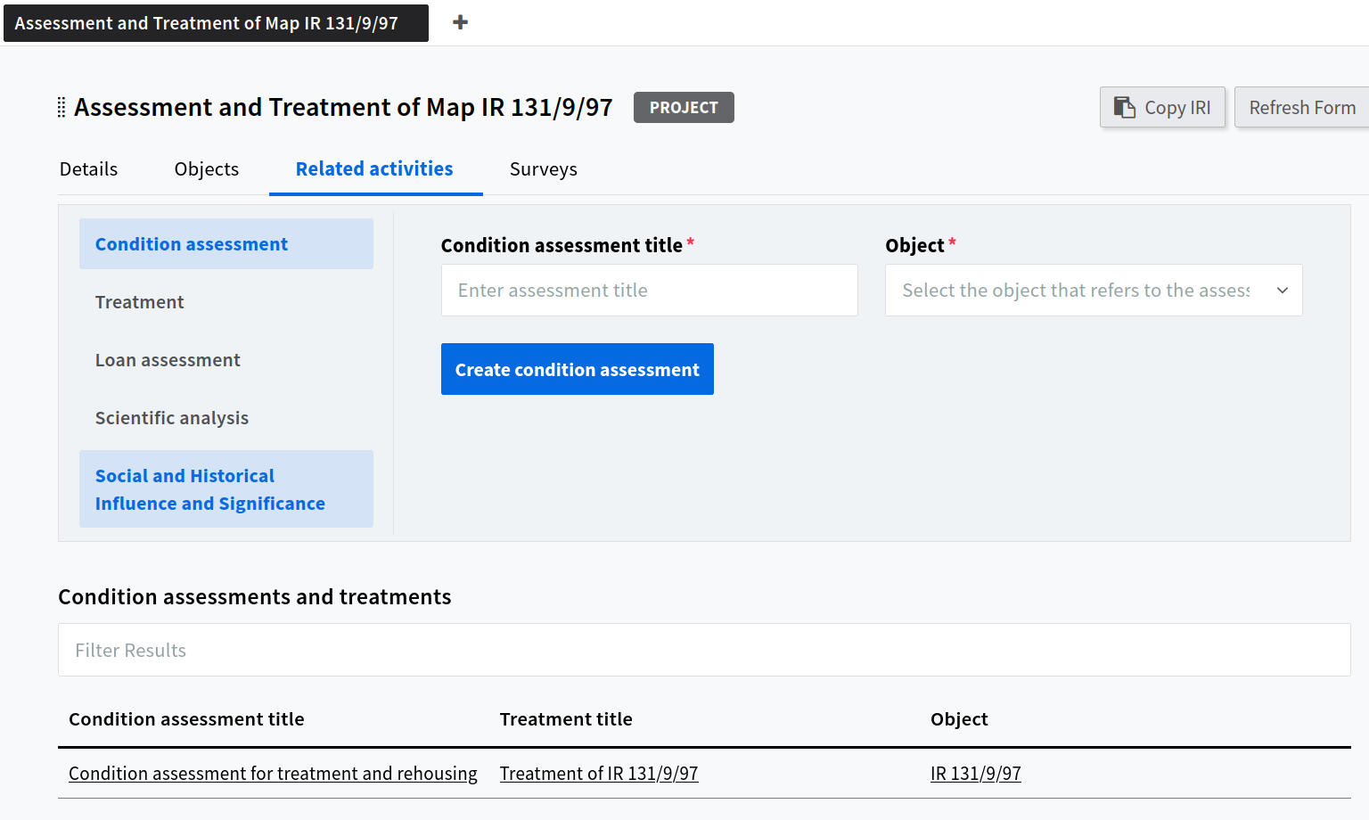
Notice that a treatment related to the assessment has also been created. A treatment would reference an assessment when it is created.
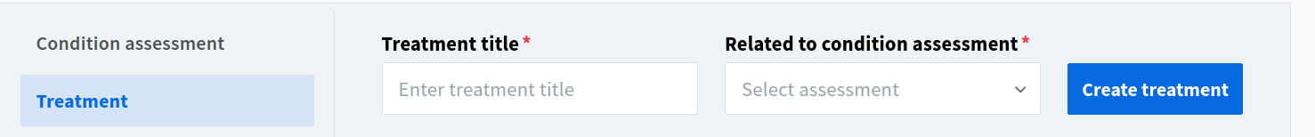
The link created by the new activity opens another frame.
Assessment
Different organisations record different information. A key factor in determining what inputs to place in the system should be based on a wide range of objectives. The following example forms are likely to change in the near future. They reflect a more administrative approach which is slowly changing to a knowledge and expert approach.
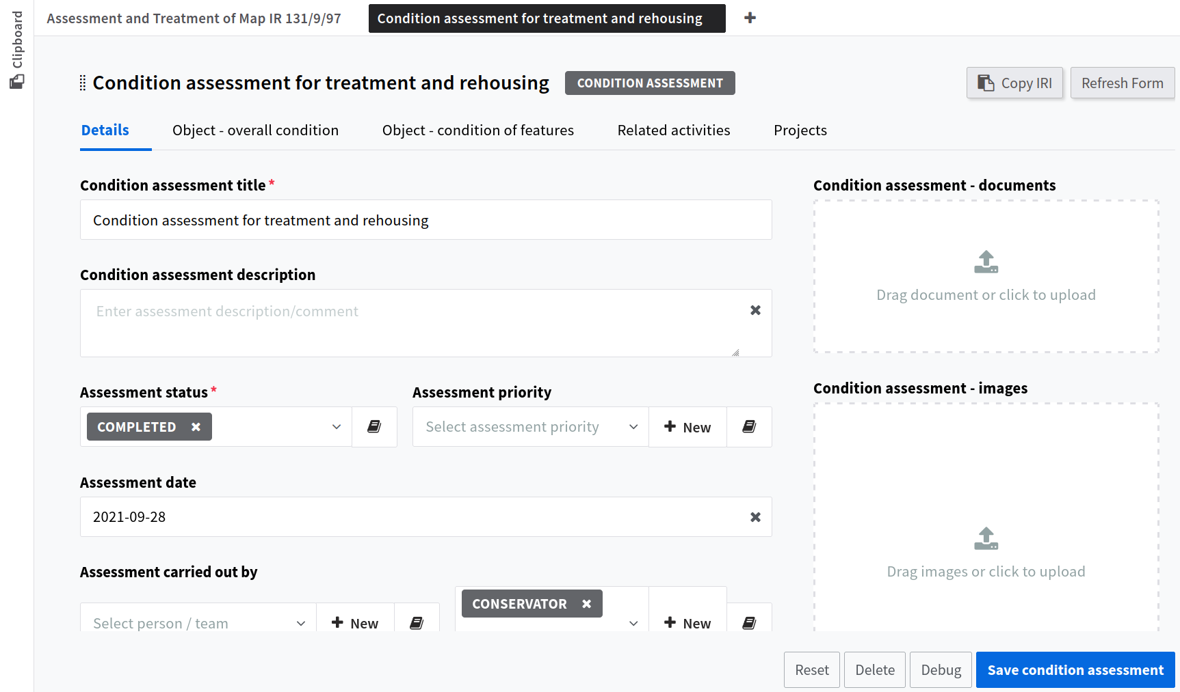
The assessment form also has a set of tabs dividing up the different information. The tabs include condition information so that multiple condition characteristics can be recorded.
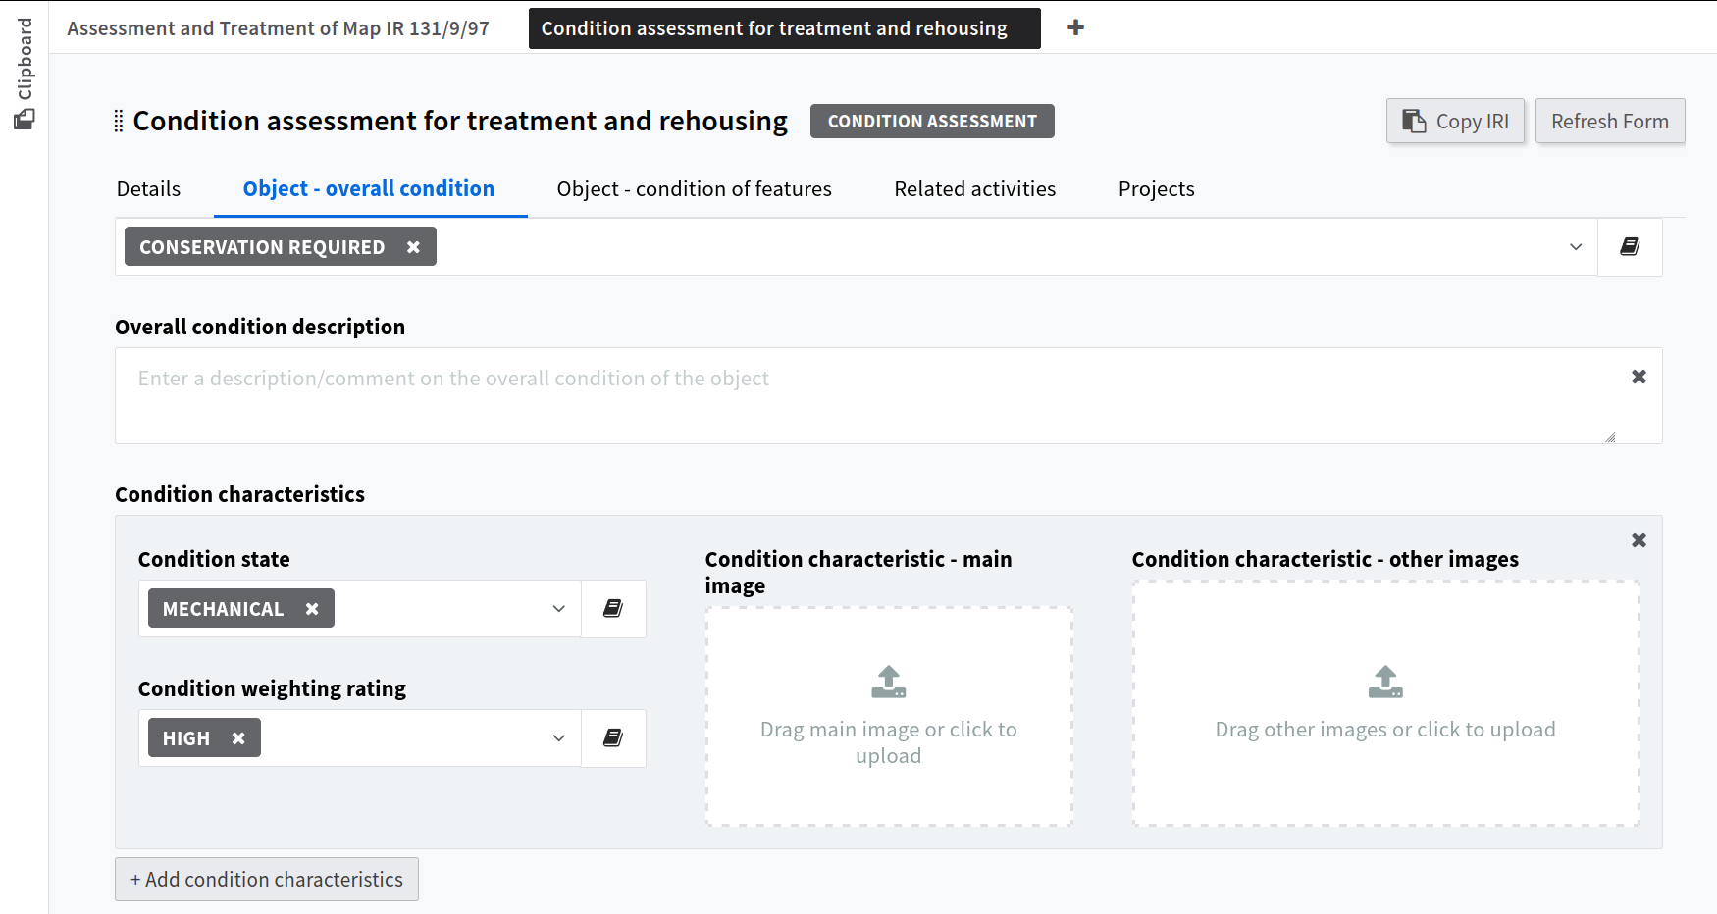
But also to identify more details of the features or aspects of the item.
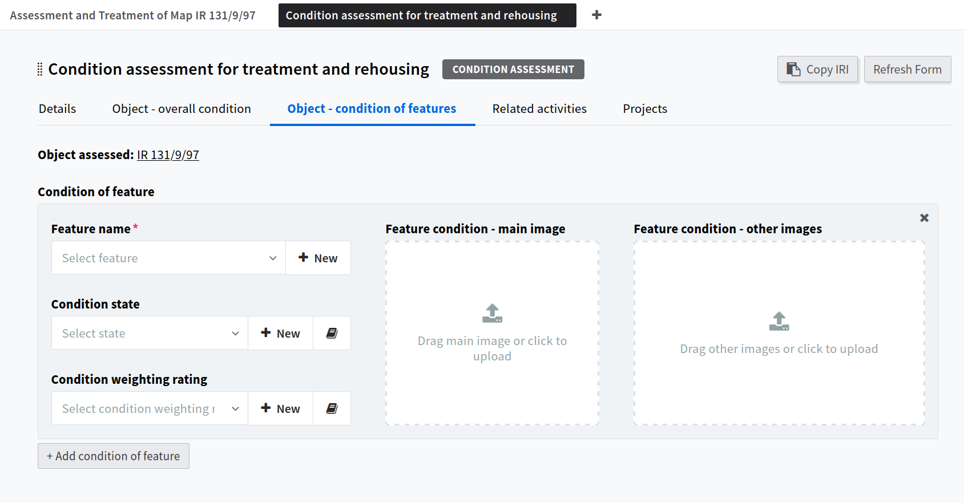
A new feature can provide descriptive and identifying information so that the feature can be easily re-examined at a later date. A new feature is started by clicking the new button at the end of the field.
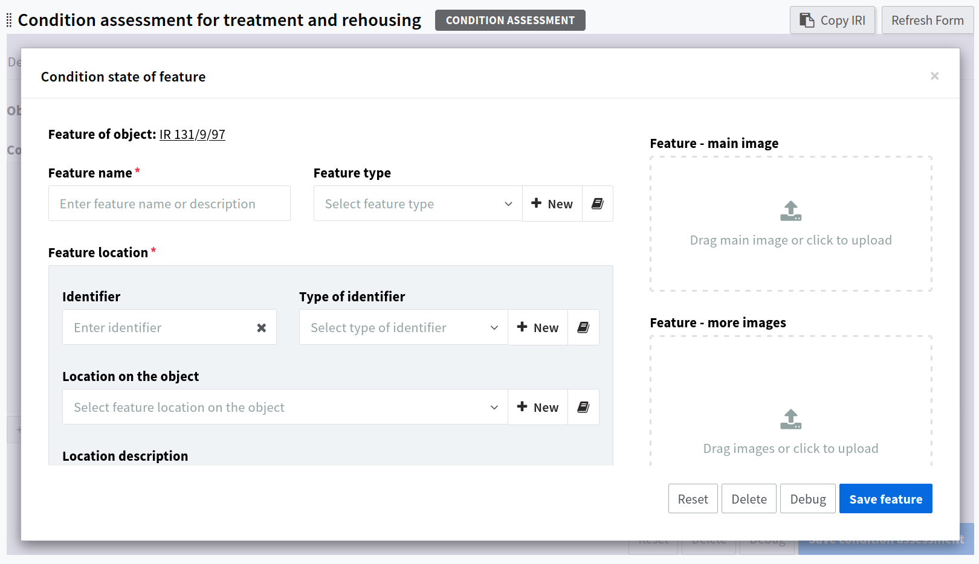
Other tabs show related activities and related projects.
Other activities have inputs related to that activity. Scientific Analysis deals with more detailed examination using specialised scientific equipment and Significance analysis deals with influence and causation, bringing in the contextual historical information that conservators and scientists used in their research and examinations.
Objects or Items
Often, organisational collection systems lack the details required to record detailed information about specific parts or aspects. The system allows conservators to break objectives into parts or features which can be identified in their own right both descriptively, with identifying marks, and with images. This not only allows the CCD department to work at a greater level of detail in a structured way, collaborate with the scientists effectively, but also contribute a richer form of information for different purposes, both practical and strategic.
Clicking an object link brings up a different form.
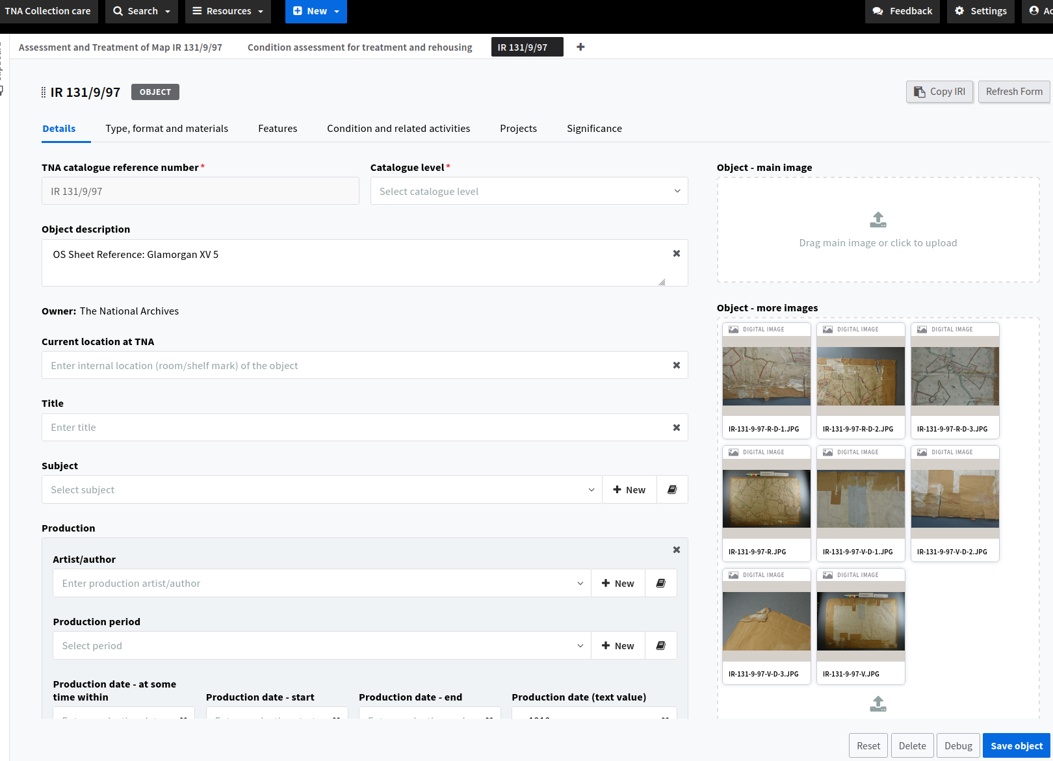
The object form is divided into basic details, material information, components (if the item is made of separate parts and features.
For example, the following item is what is known as a piece in the archive system. A piece can be a box containing parts which have not been given individual records. In this event these components can be documented and then become subject to the activities as if an officially identified item.

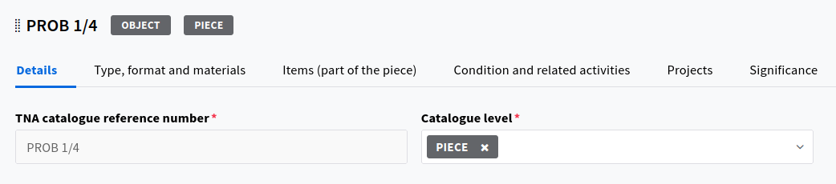

If the item is a complete object then it may be part of a piece (but have an official identifier) but the focus of attention is no the object overall but specific parts of it - for example, a part of a particular page, a seal, some part of the text of a book, and so on.
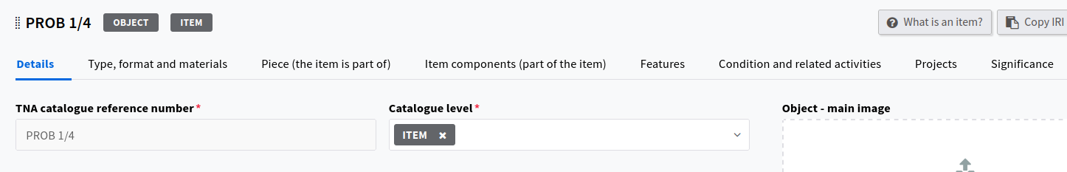
To add or create a component use the component tab.
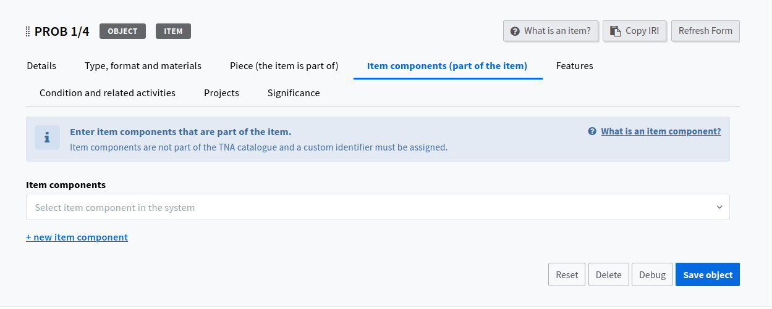
If you add a new component using the stub form this leads produces a link in a table to the new component.
Features of an item work in the same way, using the same form highlighted above.

Exhibitions and Loans
A project can be set up to support loans for an exhibition.
When starting a project you can give it an exhibition type and add exhibition information.
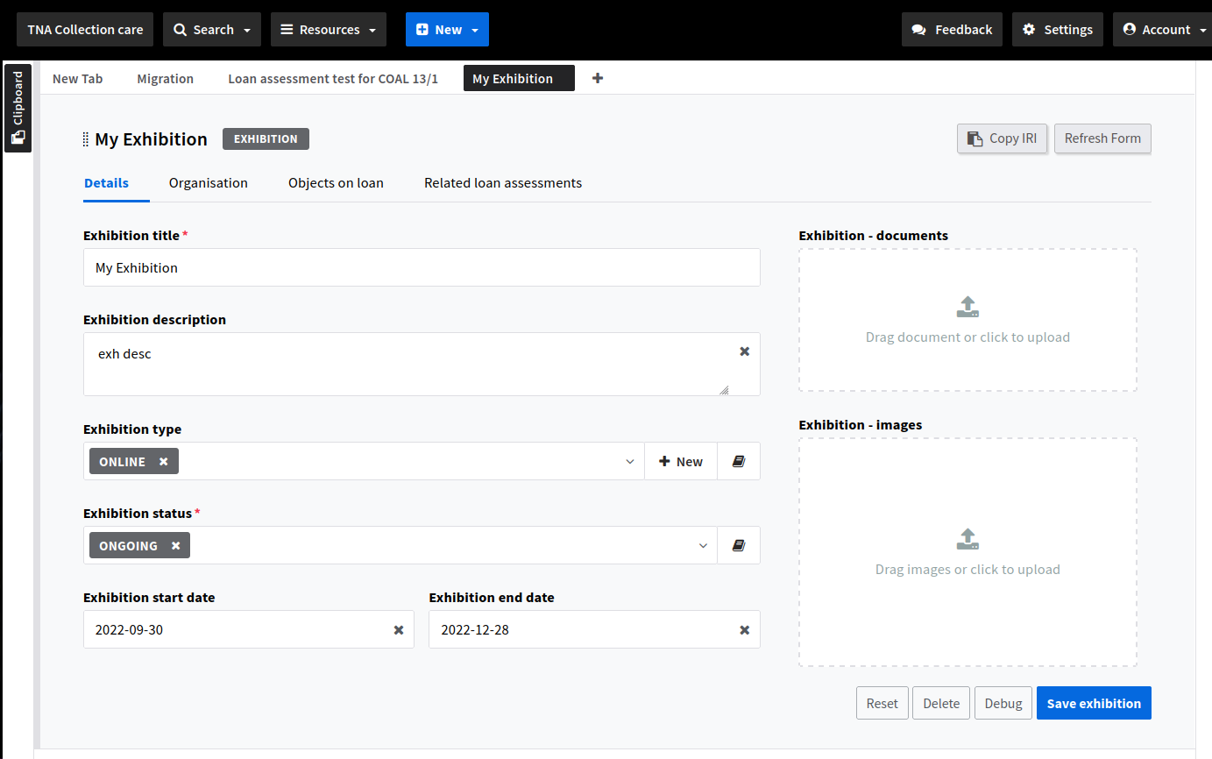
An exhibition provides details about the exhibition, the organisation and the objects being loaned. It has relations to associated condition assessments.
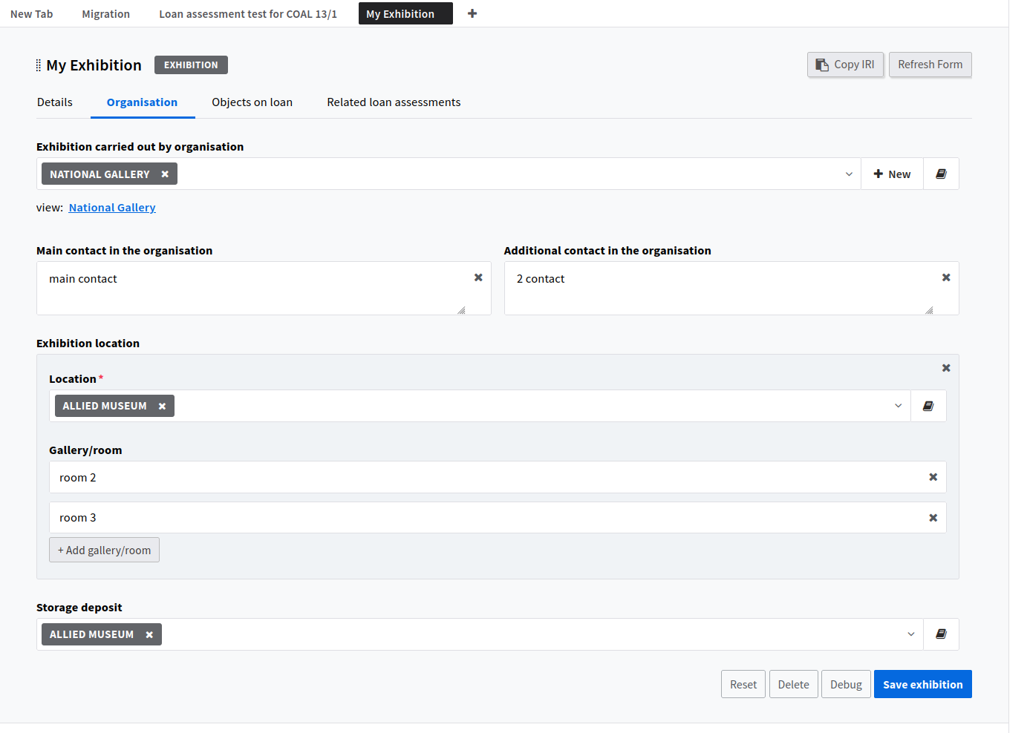
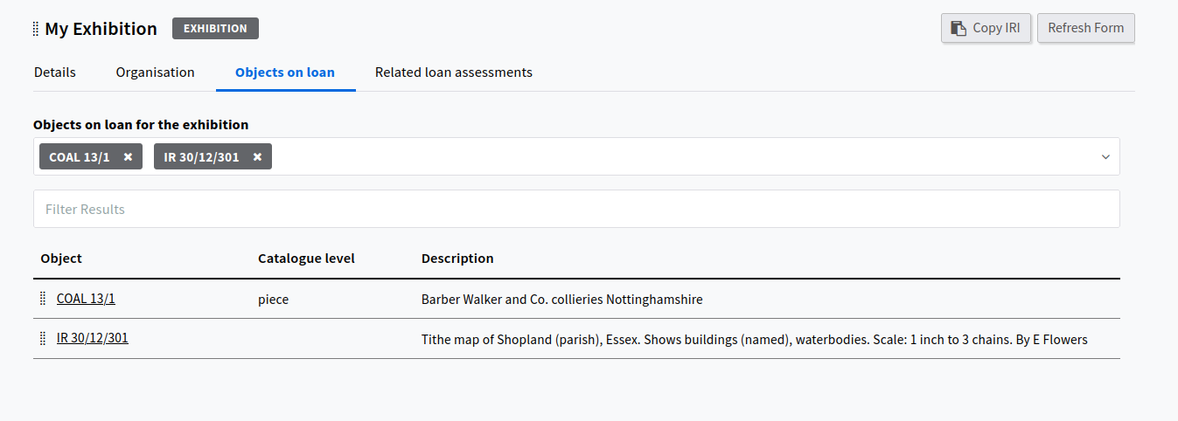
The loan process itself has a number of information areas to ensure and understanding of the conditions in which loan objects are being held.
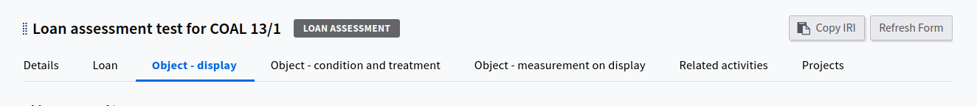
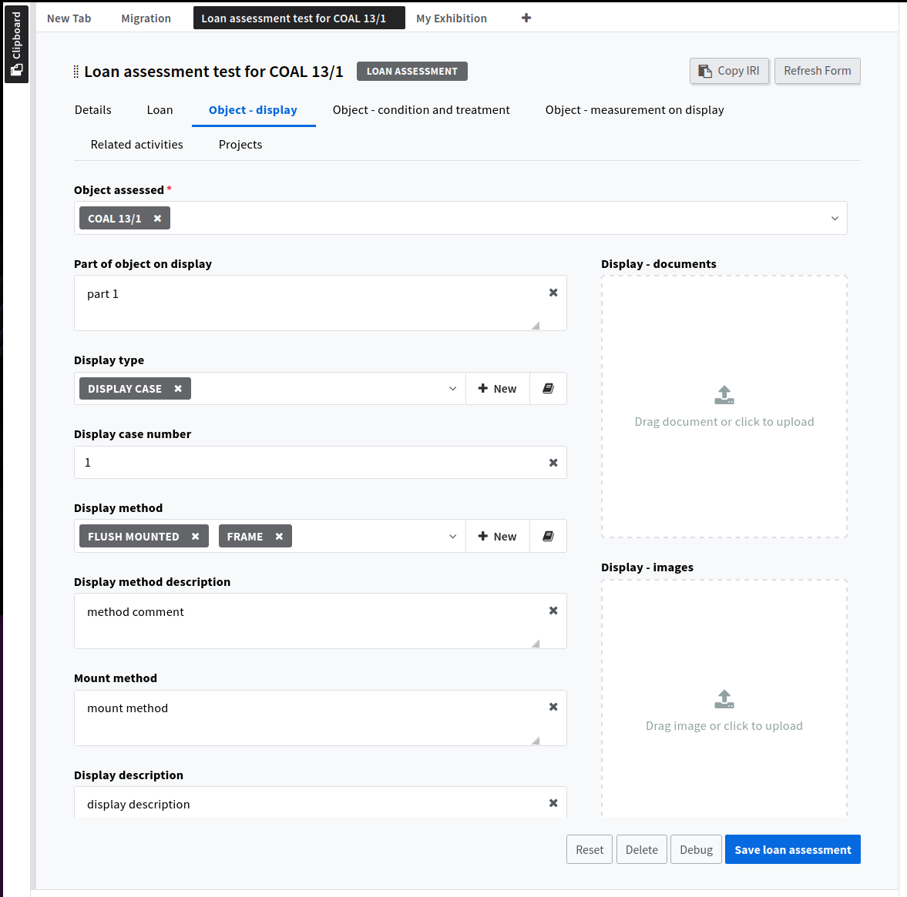
The system records the display conditions of the item.
Again, images and associated documents can be attached.

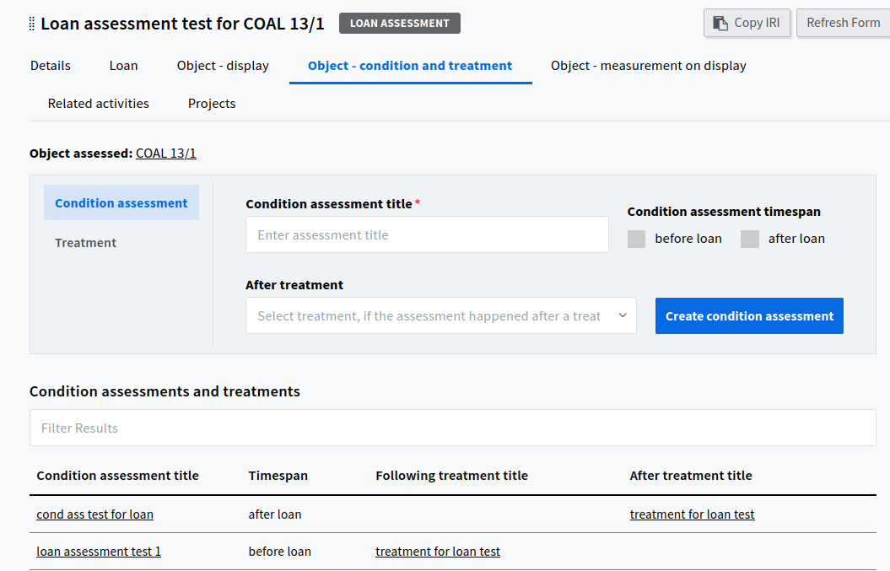
Assessment and treatments are recorded in terms of pre and post loan to reflect the need to check conditions before a loan leaves the organisation and a check when it is returned.

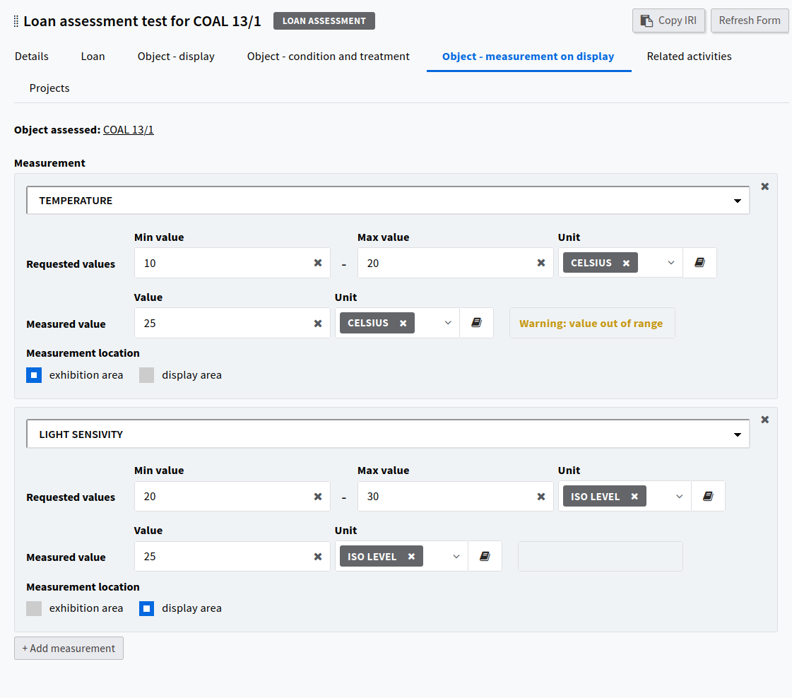
Ranges for specific types of measurement required for the loan can be specified and compared against actual values supplied from the venue.

Annex 1 - Using Images to Represent Physical features

